

REAL ESTATE WEBSITE PROJECT

A Project Report submitted at Medi-Caps University, Indore

in partial fulfilment of the degree of

**Bachelor's of Computer Applications**

**Submitted by:**

PRADHYUMN SINGH GINNARE (SC20CS301042)

MANAV RATHORE (SC20CS301034)

ANKUSH JOSHI (SC20CS301017)

**Department of Science**

**Medi-Caps University, Indore- 453 331**

**January-May 2023**

|  |  |
| --- | --- |
|  | **Medi-Caps University**  **A. B. Road, Pigdamber, Rau, Indore-453 331** |

**CERTIFICATE**

This is to certify that

Mr. PRADHYUMN SINGH GINNARE [SC20CS301042]

Mr. MANAV RATHORE [SC20CS301034]

Mr. ANKUSH JOSHI [SC20CS301017]

have completed their project entitled **‘REAL ESTATE WEBSITE’**. The project work is the requirement of Sixth (Even) Semester of the degree of Bachelor’s of Computer Applications (BCA).

Signature:…………. Signature:………….

Name: Mr. Mohsin Ali Name: Dr. Jitendra Choudhary

**(Project Guide)** **(Head of Department)**

The report has been examined and valued by us.

Signature:…………. Signature:………….

Name:……………... Name:……………...

**(Internal Examiner) (External Examiner)**

**Date: Date:**

**ACKNOWLEGMENT**

I would like to express my deepest gratitude to Honorable Chancellor, **Shri R C Mittal**, who has provided me with every facility to successfully carry out this project, and my profound indebtedness to **Prof. (Dr.) Dilip K Patnaik**, Vice Chancellor. Medi-Caps University, whose unfailing support and enthusiasm has always up my morale. I also thank **Prof. (Dr.) Abbas Ali Koser**, Dean, Faculty of Science, Medi-Caps University, for giving me a chance to work on this project. I would also like to thank my Head of the Department **Dr. Jitendra Choudhary**, for his continuous encouragement for betterment of the project

I express my heartfelt gratitude to my guide, **Mr. Mohsin Ali**, Professor, Department of Science, Medicaps University, without whose continuous help and support, this project would ever have reached the completion.

It is their help and support. Due to which we became able to complete the design and technical report.

Without their support this report would not have been possible.

**REAL ESTATE WEBSITE PROJECT**

**Content: Page No.**

|  |  |
| --- | --- |
| 1. **Introduction………………………………………………………….**    1. Objective of Project…………………………………………...….. | **6**  **6** |
| 1. **Background……………………………………………………………**   2.1 Description of existing system……………………………………..  2.2 Circumstances leading to the current new system…………………  2.3 Objective of the project……………………………………………. | **7**  **7**  **8**  **9** |
| 1. **System Requirement Analysis………………………………………..**    1. Information Gathering………………………….…………………..    2. System Feasibility………………………………………………….       1. Technical Feasibility…………………………………………       2. Operational Feasibility……………………………………….       3. Economical Feasibility…………………………………….…    3. Technologies Used………………………………………………… | **11**  **11**  **12**  **12**  **13**  **14**  **15** |
| 1. **System Requirements…………………………………………………**    1. Functional Requirements………………………………….………..    2. Non- Functional Requirements…………………………………….    3. Tools & Technologies……………………………………………...    4. Hardware Requirements………………………………….………...    5. Software Requirements……………………………………………. | **18**  **18**  **18**  **18**  **19**  **19** |
| 1. **Design Specification………………………………………….………..**    1. ER Diagram………………………………………………….……..    2. Use Case Diagram………………………………………………….    3. Data Flow Diagram………………………………………………... | **20**  **20**  **21**  **22** |
| 1. **Screenshots…………………………………………………………….**    1. Website Features…………………………………………………...    2. Database…………………………………………………………… | **23**  **23**  **30** |
| 1. **Future Scope……………………………………………………….…..** | **32** |
| 1. **Conclusion……………………………………………………………..** 2. **Reference………………………………………………………………** | **33**  **33** |

**1. Introduction**

**1.1 Objective of the Project**

The objective of the real estate website project in React JS is to provide a user-friendly platform for users to search for properties, view property details, and contact real estate agents. The website aims to simplify the process of buying or selling properties by offering a comprehensive solution that is easy to navigate and provides an excellent user experience. The objective is to make the process of buying or selling properties more accessible and convenient for users.

The website has a user-friendly interface that is easy to navigate and provides an excellent user experience.

Each property listing has a detailed page that displays more information about the property, including its features, amenities, location on the map, and contact information for the real estate agent.

Overall, the real estate website project is a comprehensive solution for people who are looking to buy or sell properties. It offers a wide range of features that make the process of finding and buying a property more accessible and convenient.

**2. Background**

## **2.1 Description of existing system**.

A real estate website typically provides a platform for property buyers, sellers, and renters to connect and exchange information. The website may include a searchable database of properties that are available for sale, rent or lease, along with detailed property descriptions, photos, and videos. Users can typically search for properties based on their preferred location, price range, property type, and other criteria.

Many real estate websites also offer tools and resources to help users make informed decisions about buying, selling or renting properties. These may include mortgage calculators, property valuation tools, and neighborhood guides that provide information about local schools, amenities, and crime rates.

In addition to property listings, some real estate websites may also offer services such as property management, real estate agent referrals, and home improvement resources. Some websites may also feature real estate news and trends, as well as forums or discussion boards where users can share information and ask questions.

**2.2 Circumstances leading to the current new system**

The phase of system analysis process deals with problems that are affecting in the current manual system. The problems are those, which are affecting the organization in its daily routine work.

It’s possible that advancements in technology and changes in consumer behavior may have contributed to the development of new and improved real estate websites. For example, the widespread use of mobile devices has made it easier for people to search for properties on-the-go, leading to the development of mobile-friendly real estate websites and apps. Additionally, the rise of social media and online reviews has increased the importance of online reputation and customer service for real estate agents and companies, leading to a greater focus on user experience and engagement on real estate websites.

As the growing trend in InfoTech World of computers need of accuracy, perfect ness, speed and high memory data storage is a must. Each and every problem must be solved with a least amount of time and energy.

The problems faced by existing system are described as below:

* Difficulty in Maintenance of Records.
* Time Consuming.
* Editing of data becomes a tedious job.
* No Security of Data.
* Mistakes Occurring in long Calculations.
* Proper Generation of Report.
* Lack of Efficiency and Man Power.
* High Data Redundancy.
* Data Inconsistency.

**2.3 Objective of the project**

It is a Website project which is designed to simplify the process of Real Estate. In Real Estate there are lots of calculations like keeping record of Properties in terms of location, rate, number of registered members, and especially calculations of Loan EMI calculation concept at the time of transaction etc. These calculations are not only complicated but also brain eating. Our project also consists of tables to store, individual detail of property, customer's details, and feedback's details.

So the owner can have all these details in his personal computers rather than having hundreds of registers. The information about these applications is the following sections. So the project entitled "Real Estate Website" is an end user Website. The Real estate Website we are designing that helps the Developer to handle those task that had been handled manually.

The tasks like:

* Seeping record of properties available,
* Stores & gives details of properties,
* Maintaining record of customers visited his website,
* Displays information of customers.
* Displays information properties.
* Displays information of location.
* Displays information of location placed by customer.

The main objective of the project on real estate management system is to manage the details of property types buyers sellers property types approvals. It manages all the information about property types, registrations, approvals. The project is totally built add administrative end and thus only the administrator is guaranteed the access. The purpose of the project is to build an application program to reduce the manual work for managing the property types buyers, registrations, sellers It tracks all the details about the sellers, property types, approvals.

Functionality is provided by property types management system are as follows:

* Provides the searching facilities based on various factors. Such as property types, sellers, approvals.
* Real estate management system also managed the registration details online for property type details, approval details.
* Manage the information of buyers.
* Shows the information and description of the property types, sellers.
* It deals with monitoring the information and transactions of property types.
* Auditing, adding and updating of records is improved which results in proper resource management of property types data.

**3. System Requirement Analysis**

**3.1 Information Gathering**

* Information gathering in any Real Estate Website Project is not an easy task. It has to be gathered in an organized way so that

(a) Seeping record of properties.

(b) Stores & gives details of properties.

(c) Maintaining record of customers.

(d) Information of location placed by customer

(e) Wrong or incomplete details are not collected.

* To do this, a proper search strategy must be decided first, search strategy includes selecting information sources and search methods.
* It also includes modeling methods to make sense out of information so collected.
* Here an overall idea about the search methods or fact gathering techniques which are used while gathering the information, they are:

(1) Interviewing.

(2) Record inspection.

(3) Observation.

* These techniques are used in system analysis and design stage.

**3.2 System Feasibility**

Preliminary investigation examine project feasibility, the likelihood the system will be useful to the organization. The main objective of the feasibility study is to test the Technical, Operational and Economical feasibility for adding new modules and debugging old running system. All system is feasible if they are unlimited resources and infinite time. There are aspects in the feasibility study portion of the preliminary investigation:

* Technical Feasibility
* Operational Feasibility
* Economical Feasibility

**3.2.1 Technical Feasibility**

The technical issue usually raised during the feasibility stage of the investigation includes the following:

* Does the necessary technology exist to do what is suggested?
* Do the proposed equipment’s have the technical capacity to hold the data required to use the new system?
* Will the proposed system provide adequate response to inquiries, regardless of the number or location of users?
* Can the system be upgraded if developed?
* Are there technical guarantees of accuracy, reliability, ease of access and data security?

Earlier no system existed to cater to the needs of ‘Secure Infrastructure implementation System’. The current system developed is technically feasible. It is a web based user interface for audit workflow at NIC-CSD. Thus it provides an easy access to the users. The database’s purpose is to create, establish and maintain a workflow among various entities in order to facilitate all concerned users in their various capacities or roles. Permission to the users would be granted based on the roles specified.

Therefore, it provides the technical guarantee of accuracy, reliability and security. The software and hard requirements for the development of this project are not many and are already available in-house at NIC or are available as free as open source. The work for the project is done with the current equipment and existing software technology. Necessary bandwidth exists for providing a fast feedback to the users irrespective of the number of users using the system.

**3.2.2 Operational Feasibility**

Proposed projects are beneficial only if they can be turned out into information system. That will meet the organization’s operating requirements. Operational feasibility aspects of the project are to be taken as an important part of the project implementation. Some of the important issues raised are to test the operational feasibility of a project includes the following:-

* Is there sufficient support for the management from the users?
* Will the system be used and work properly if it is being developed and implemented?
* Will there be any resistance from the user that will undermine the possible application benefits?

This system is targeted to be in accordance with the above-mentioned issues. Beforehand, the management issues and user requirements have been taken into consideration. So there is no question of resistance from the users that can undermine the possible application benefits.

The well-planned design would ensure the optimal utilization of the computer resources and would help in the improvement of performance status.

**3.3.3 Economical Feasibility**

A system can be developed technically and that will be used if installed must still be a good investment for the organization. In the economical feasibility, the development cost in creating the system is evaluated against the ultimate benefit derived from the new systems. Financial benefits must equal or exceed the costs.

The system is economically feasible. It does not require any addition hardware or software. Since the interface for this system is developed using the existing resources and technologies available at NIC, There is nominal expenditure and economical feasibility for certain.

**3.3 Technologies Used**

* **React JS**

React JS is a powerful JavaScript library that has revolutionized the way developers build user interfaces. Its popularity is due to its ability to create reusable UI components and build complex applications with ease. Developed by Facebook, React JS has become one of the most widely used libraries in web development.

One of the key features of React JS is its virtual DOM, which makes it fast and efficient when rendering changes to the UI. The virtual DOM allows React to update only the parts of the UI that have changed, rather than re-rendering the entire page. This results in faster load times and a smoother user experience.

Another advantage of React JS is its declarative approach to programming. Developers can describe what they want the UI to look like, and React takes care of the rest. This makes it easy to understand and maintain code, even as projects grow in complexity.

React JS also has a large ecosystem of tools and libraries that make it even more powerful. This includes tools for testing, debugging, and optimizing performance. Additionally, React JS can be used with other libraries and frameworks, such as Redux and Angular, to build even more complex applications.

Overall, React JS is a valuable tool for any developer looking to create modern, responsive web applications. Its flexibility and scalability make it a popular choice for large-scale projects, while its ease of use and efficient rendering make it ideal for smaller projects as well. With its growing popularity and extensive community support, React JS is sure to remain a top choice for web developers for years to come.

* **Tailwind CSS**

Tailwind CSS is a popular utility-first CSS framework that has gained a lot of attention in recent years. It is designed to help developers quickly create responsive and customizable user interfaces with minimal effort. Tailwind CSS is known for its extensive set of pre-defined classes that can be used to style any HTML element.

One of the key features of Tailwind CSS is its focus on utility classes. These classes can be used to apply specific styles to an element, such as padding, margin, or text alignment. This allows developers to quickly create complex layouts without having to write custom CSS code. The framework also includes a wide range of pre-defined color palettes, typography settings, and other design elements.

Another advantage of Tailwind CSS is its flexibility. The framework can be customized to fit the needs of any project, with options to modify the default settings, add new classes, or remove unnecessary ones. This makes it easy to maintain consistency across a project while still allowing for unique design choices.

Tailwind CSS also includes a number of helpful features for responsive design. Classes can be used to adjust the layout and styling of elements based on screen size, making it easy to create mobile-friendly interfaces. The framework also includes pre-defined breakpoints and responsive utilities for common design patterns.

Overall, Tailwind CSS is a powerful tool for web developers looking to create responsive and customizable user interfaces quickly. Its focus on utility classes and flexibility make it a popular choice for projects of all sizes. With a growing community and extensive documentation, Tailwind CSS is sure to remain a top choice for web developers in the years to come.

* **Firebase**

Firebase is a popular mobile and web application development platform that was acquired by Google in 2014. It provides developers with a wide range of tools and services to help them build high-quality applications quickly and easily. Firebase is known for its real-time database, authentication, cloud messaging, and hosting services, among others.

One of the key features of Firebase is its real-time database. This database allows developers to store and sync data in real-time across multiple devices and platforms. This makes it easy to build collaborative applications that can be used by multiple users at the same time. The database is also scalable, meaning it can handle large amounts of data without slowing down or crashing.

Firebase also includes a powerful authentication service that allows developers to add secure user authentication to their applications. This service supports a wide range of authentication methods, including email and password, social media login, and phone number verification. This makes it easy for developers to add user authentication to their applications without having to write complex code.

Firebase also includes a hosting service that allows developers to host their applications on Google’s secure and reliable servers. This service is easy to use and provides developers with a range of customization options to ensure their application looks and performs exactly as they want it to.

Overall, Firebase is a powerful tool for mobile and web application development. Its real-time database, authentication, cloud messaging, and hosting services make it easy for developers to build high-quality applications quickly and easily. With a growing community and extensive documentation, Firebase is sure to remain a top choice for developers in the years to come.

**4. System Requirements**

**4.1 Functional Requirements**

* User registration and login functionality.
* Detailed property listings with photos.
* Contact form for users to connect with real estate agents.
* Mobile-responsive design for seamless user experience on all devices.
  1. **Non-functional Requirements**
* Security measures to protect user data and prevent unauthorized access.
* High website performance with fast page loading times and minimal downtime
* Scalability to accommodate a growing number of users and property listings
* Compatibility with multiple browsers and operating systems
* User-friendly interface with intuitive navigation and clear calls-to-action.
* The website is open for 24*7 hours.
  1. **Tools and Technologies**
* **Operating system:** windows 11, 64-bit operating system.
* **Development environment:** Visual Studio Code, Chrome.
* **Language:** React JS, Tailwind CSS.
* **Database:** Firebase.
  1. **Hardware Requirement**

Most current Computers and Laptop have enough specifications to be used to create an Application. The most important specification to check on the computer would be the size of the RAM, which should be over 2 GB, more is better. This will ensure that the computer runs quickly and smoothly, even with heavier programs. The computer should have a keyboard and mouse attached and working as well.

|  |  |  |
| --- | --- | --- |
| **S.NO** | **NAME** | **HARDWARE** |
| 1. | Processor | Intel dual core (32 bit) |
| 2. | RAM | 2 GB |
| 3. | Processor Speed | 2 GHz |

* 1. **Software Requirement**

Aside from a Computer and internet connection, most of the tools you need to build an Application are Software Program. Some of which may already be on your computer.

|  |  |  |
| --- | --- | --- |
| **S.NO** | **NAME** | **SOFTWARE** |
| 1. | Operating System | Windows 11, 64-bit operating system. |
| 2. | Language Used | React JS, Tailwind CSS |
| 3. | Web Browser | Google Chrome |

**5. Design Specification**

**5.1 ER Diagram**

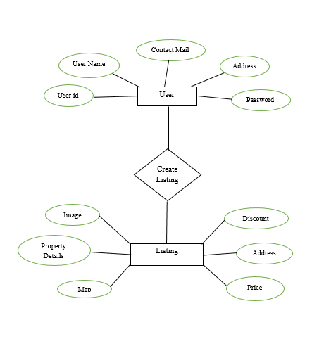

**Fig: ER Diagram**

**5.2 Use Case Diagram**

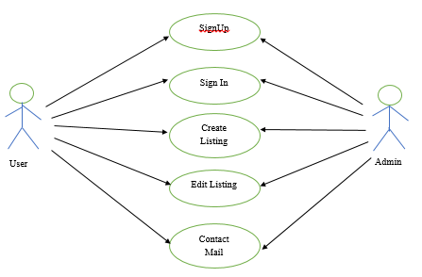

**Fig: Use Case Diagram**

**5.3 Data Flow Diagram**

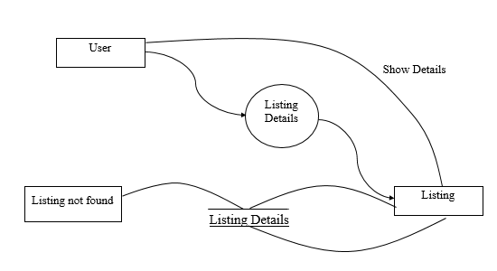

**Fig: Data Flow Diagram**

**6. Screenshots**

**6.1 Website Features**

* **Home Page**

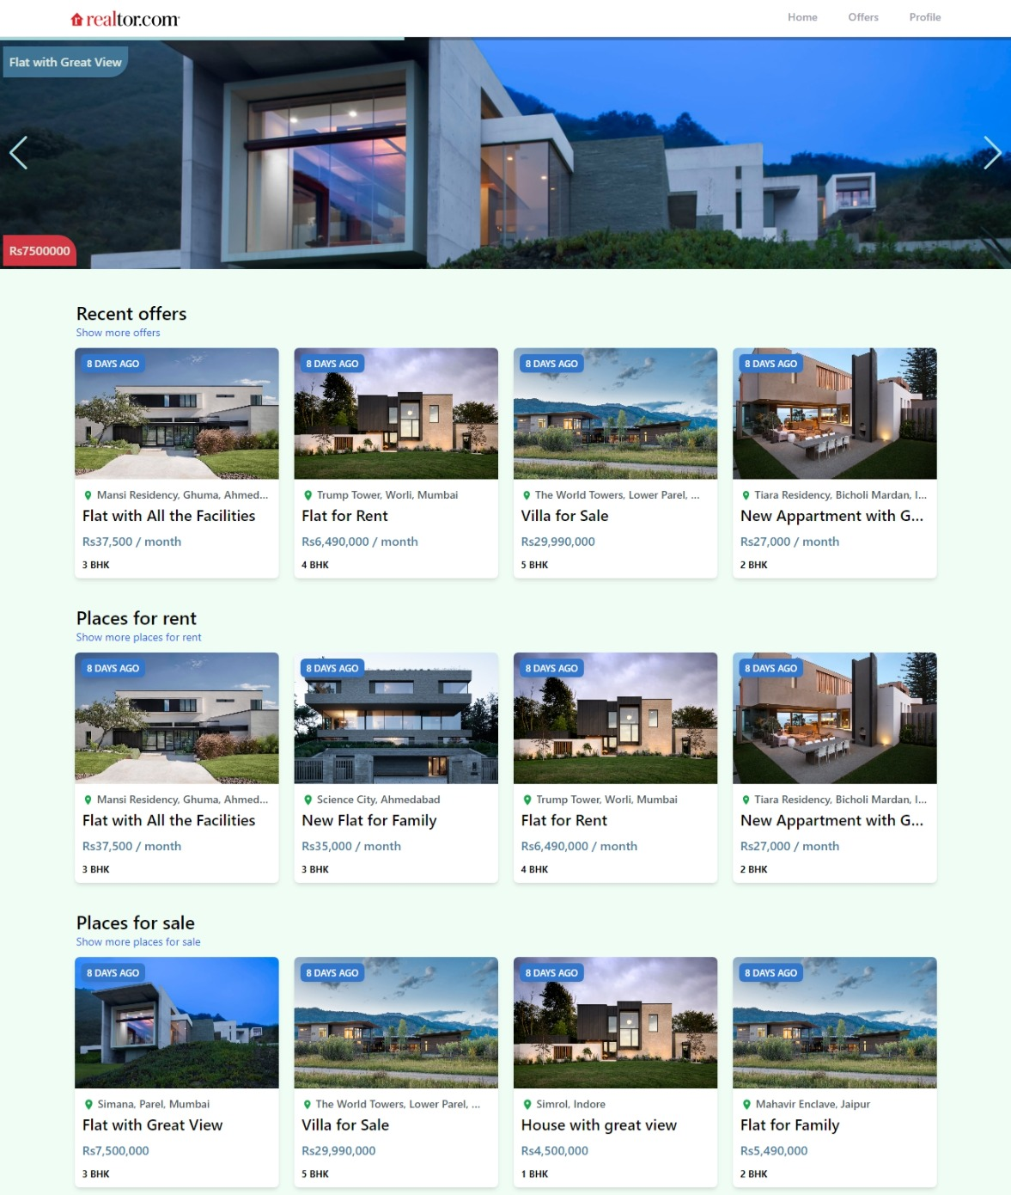

* **Offers Page**

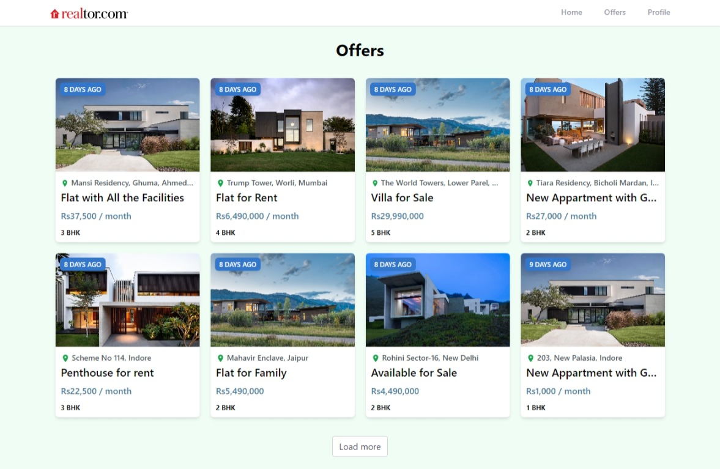

* **Sign In Page**



* **Sign In with Google**

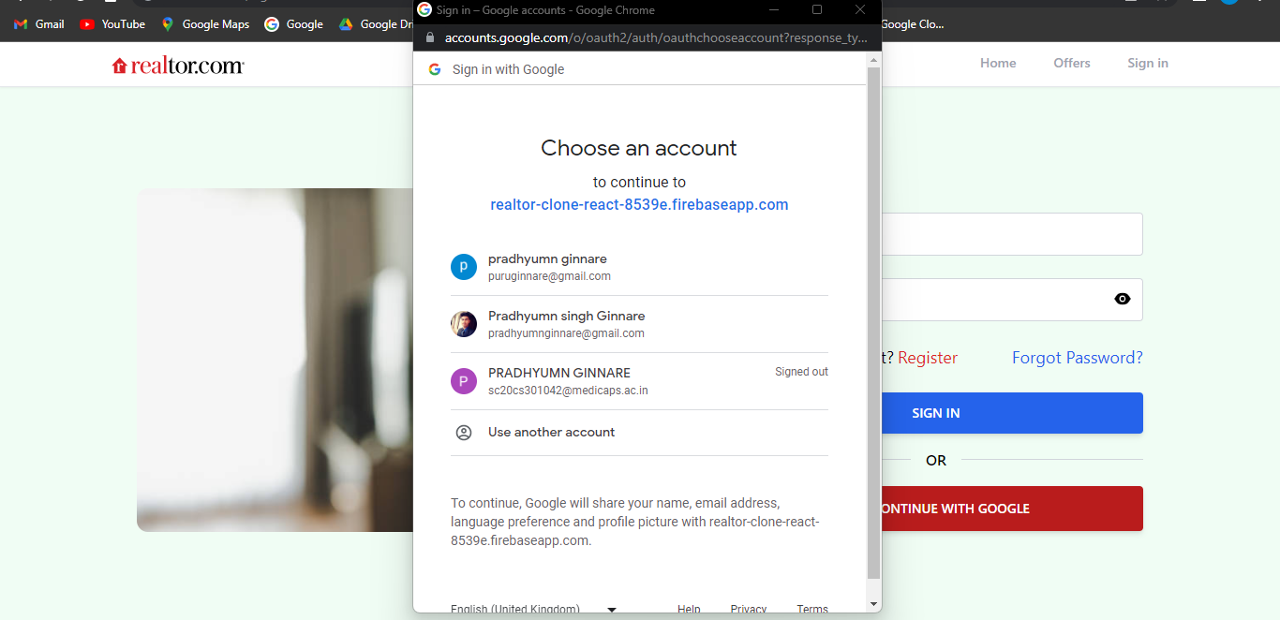

* **Sign Up Page**

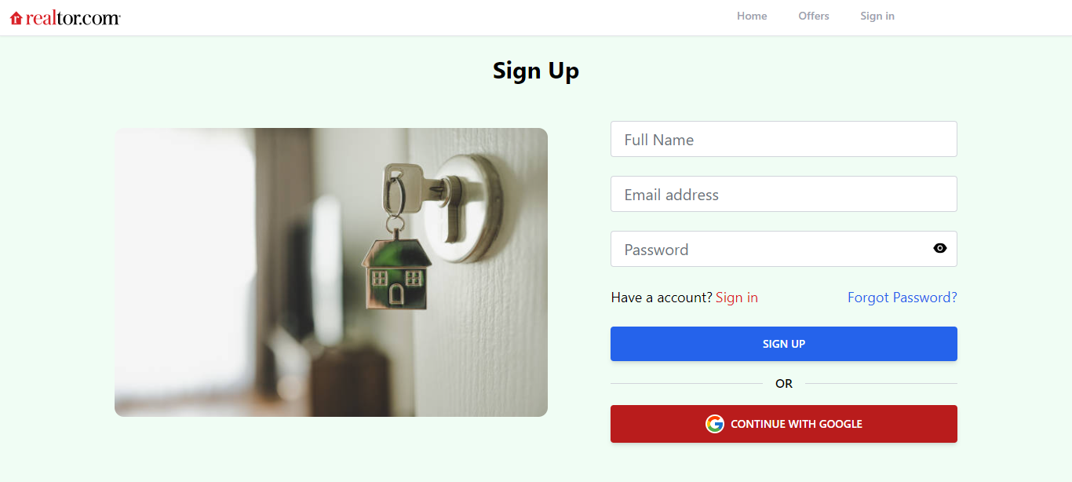

* **Forgot Password Page**



* **Profile Page**

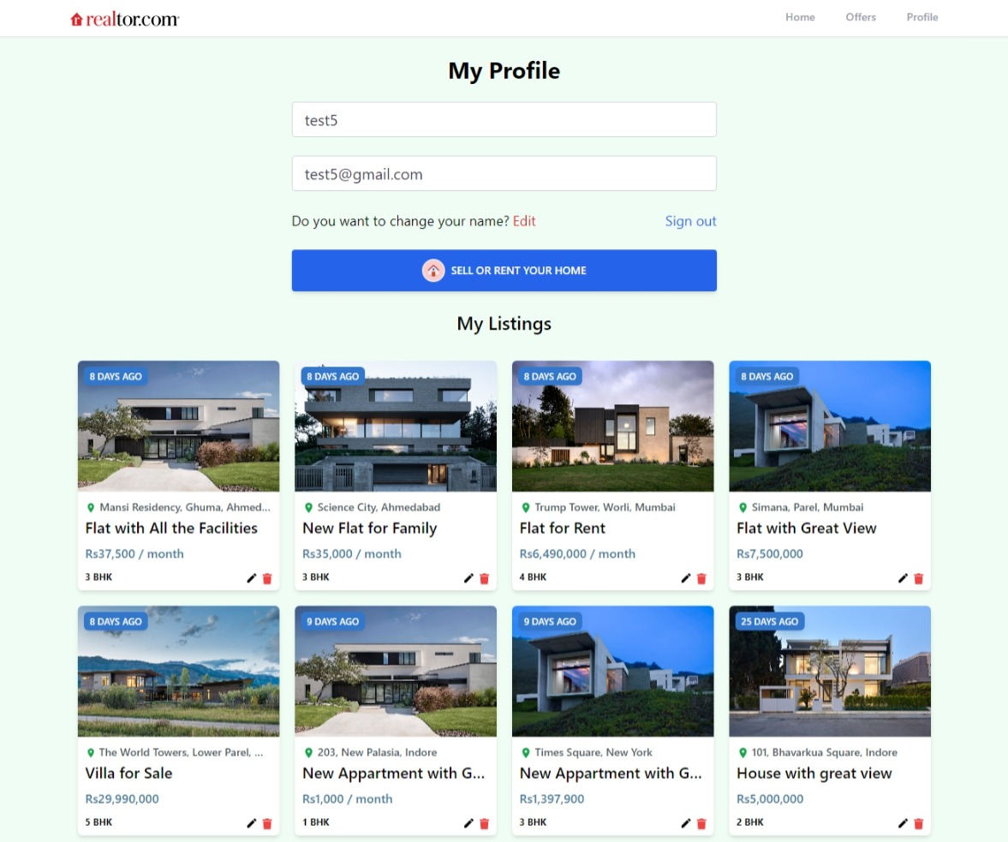

* **Create Listing Page**

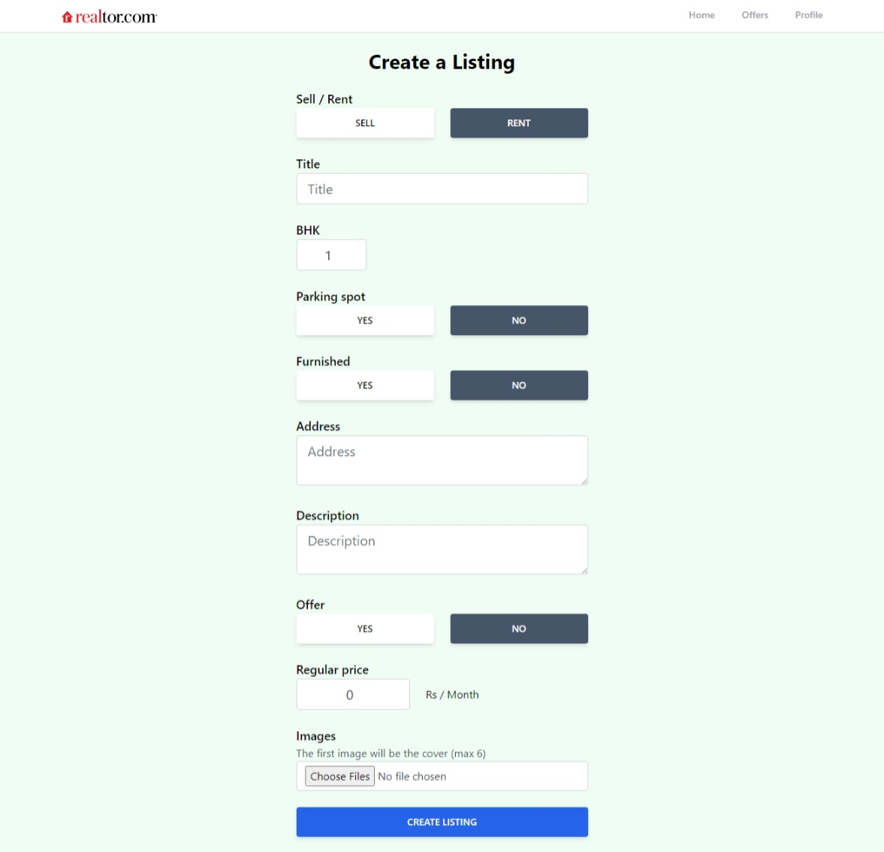

* **Edit Listing Page**

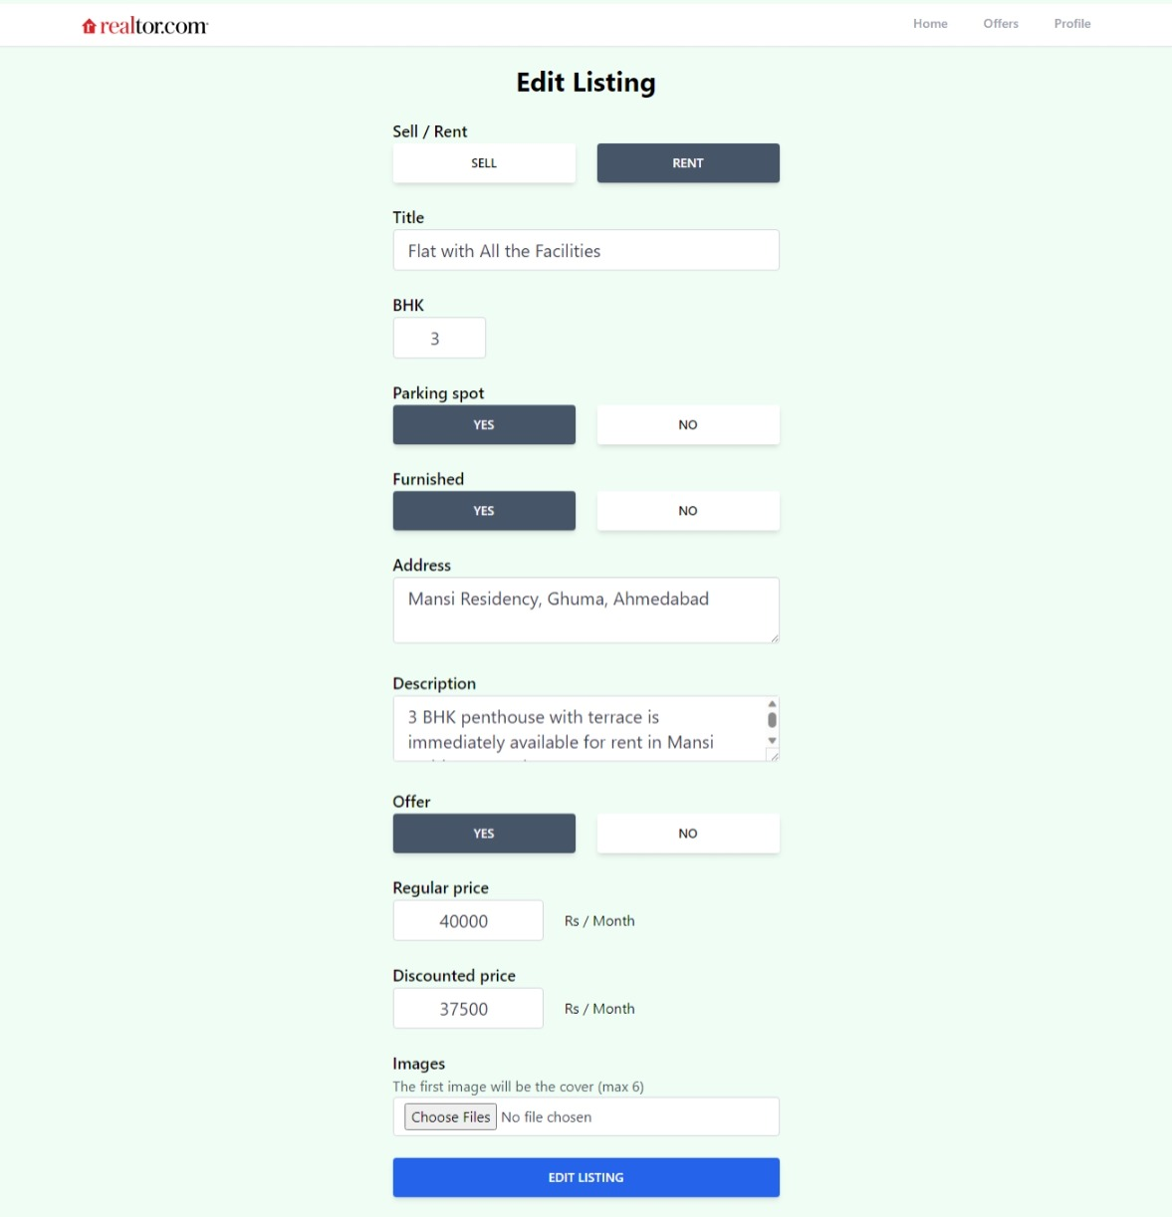

**6.2 Database**

* **Authentication**

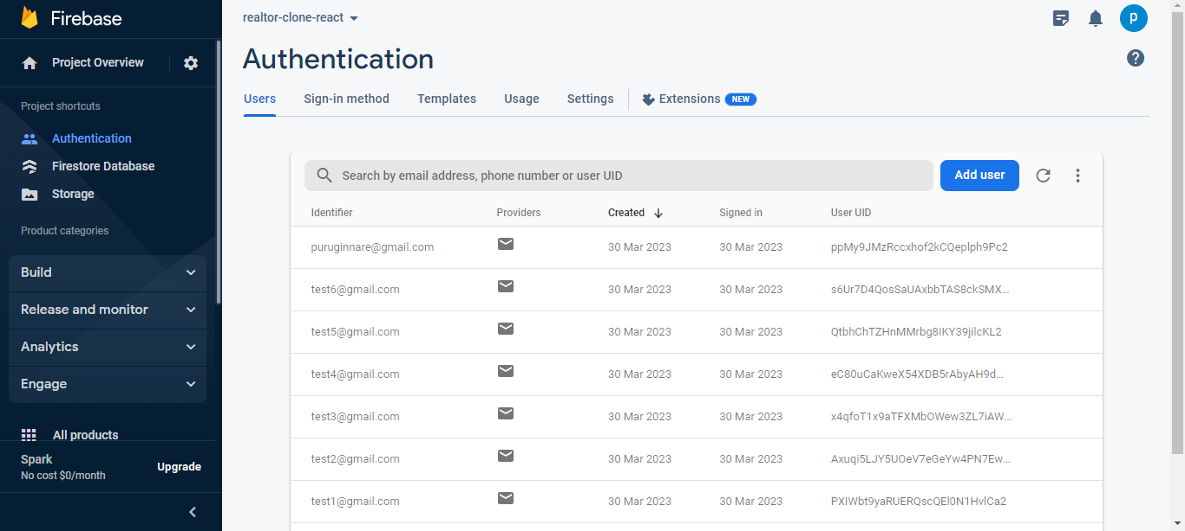

* **Firestore Database**

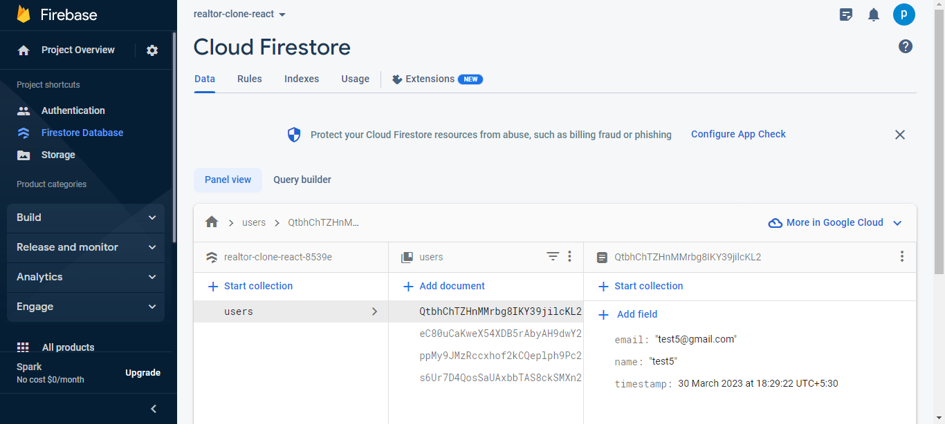

* **Storage**

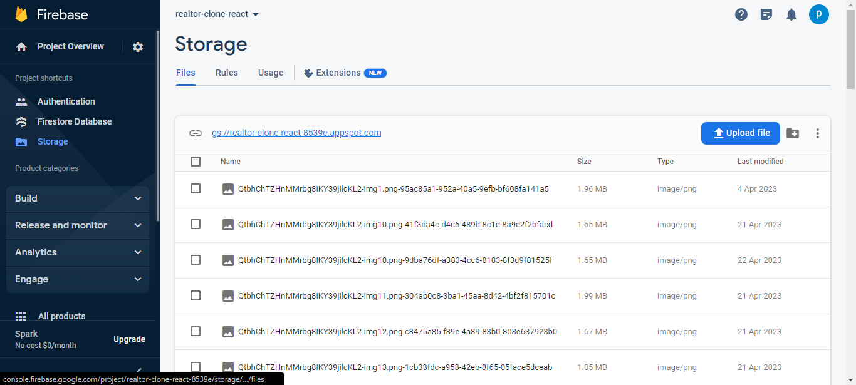

**7. Future Scope of Project**

* Integration with Artificial Intelligence (AI) and Machine Learning (ML) technologies to provide personalized property recommendations based on user preferences, search history, and behavior patterns.
* Use of Virtual Reality (VR) and Augmented Reality (AR) technologies to offer immersive property tours and enable buyers to visualize the property before making a purchase decision.
* Integration with blockchain technology to facilitate secure and transparent property transactions, including property ownership records, title transfers, and payment processing.
* Implementation of predictive analytics and data-driven insights to provide real-time market trends, property valuations, and investment opportunities.
* Integration with social media platforms to enable users to share properties with their network, receive feedback, and connect with potential buyers or sellers.
* Use of chatbots and natural language processing (NLP) technologies to provide instant customer support, answer queries, and assist users in finding the right property.
* Integration with mobile apps to provide seamless access to the real estate platform on-the-go, including property search, booking appointments, and receiving notifications.
* Overall, the future scope of a real estate website project in React JS is vast, and developers can leverage emerging technologies to create innovative and user-friendly platforms that cater to the evolving needs of the real estate market.

**8. Conclusion**

In Conclusion, the real estate website project has been successfully developed and launched. The website offers an intuitive user interface that enables users to search for properties easily and efficiently. The site is optimized for both desktop and mobile devices, ensuring a seamless experience for users across all platforms. Additionally, the website provides a range of useful features such as detailed property listings, property valuations, and neighborhood guides. With a focus on user experience and functionality, the real estate website project aims to provide a valuable resource for those seeking to buy or sell properties.

**Overall, the real estate website project is a success. It offers a valuable resource for anyone who is seeking to buy or sell properties, and its user-friendly interface and range of functionalities make it a standout website in the real estate industry. The website is set to make a significant impact in the real estate market.**

**9. Reference**

https://en.wikipedia.org/

https://legacy.reactjs.org/

https://www.javatpoint.com/

https://www.w3schools.com/

https://www.tutorialspoint.com/

https://react.dev/reference/react/